Outputs

Superset ID : 6124988

Data Structures and Algorithms

1. [EcommerceSearchSystem](https://github.com/Hemanth2415/Digital-Nurture-4.0-JavaFSE/tree/main/Week%20-%201/Data%20Structures%20and%20Algorithms/EcommerceSearchSystem)

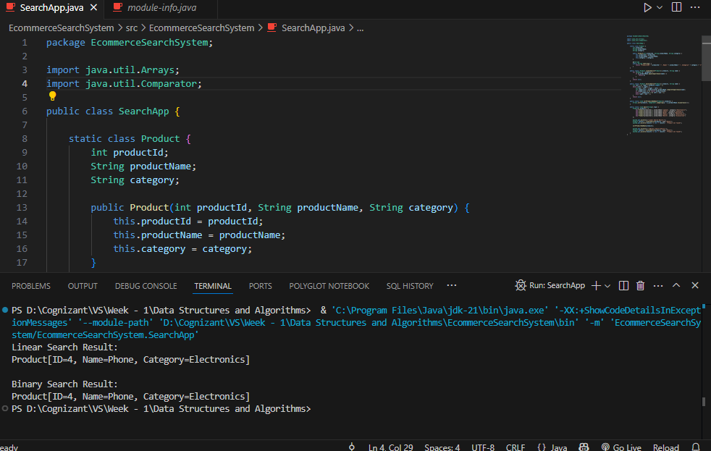

1. [FinancialForecastingTool](https://github.com/Hemanth2415/Digital-Nurture-4.0-JavaFSE/tree/main/Week%20-%201/Data%20Structures%20and%20Algorithms/FinancialForecastingTool) 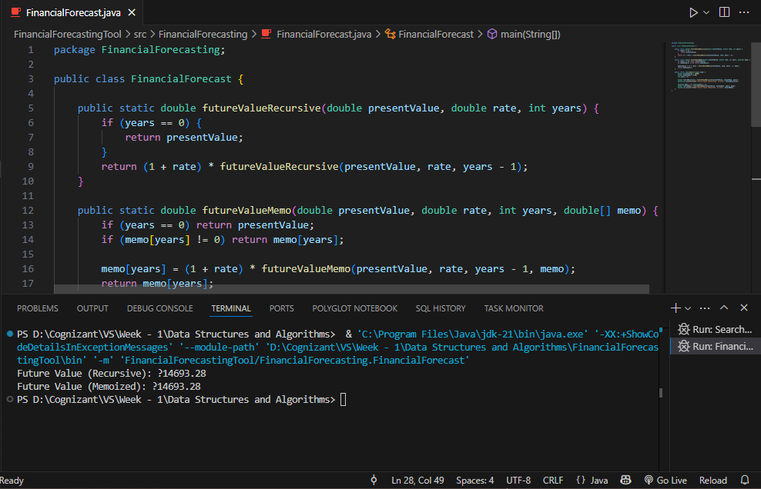

Design patterns and principles

1. [FactoryMethodPatternExample](https://github.com/Hemanth2415/Digital-Nurture-4.0-JavaFSE/tree/main/Week%20-%201/Design%20Patterns/FactoryMethodPatternExample)

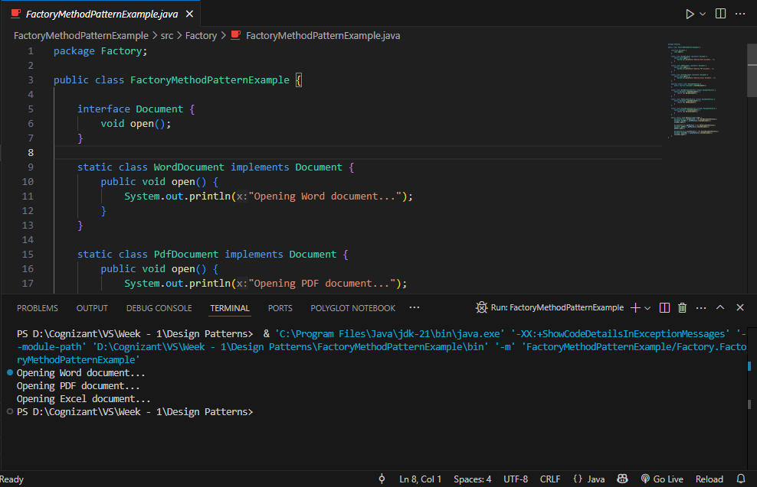

1. [SingletonPatternExample](https://github.com/Hemanth2415/Digital-Nurture-4.0-JavaFSE/tree/main/Week%20-%201/Design%20Patterns/SingletonPatternExample)

